**Lesson 2: Mathematical Models and an Inventory of Fundamental Functions**

After completing this lesson, you should be able to

* describe mathematical modeling
* create linear models
* discuss polynomial functions
* discuss power functions
* discuss rational functions
* discuss algebraic functions
* discuss trigonometric functions
* discuss exponential functions
* discuss logarithmic functions
* discuss transcendental functions

**Commentary**

**Topics**

1. [Introduction to Mathematical Modeling](https://umuc.equella.ecollege.com/file/7bdece95-b196-4233-9313-aa904663b08e/1/MATH140-0909.zip/Modules/M1-Module_1/Lesson_2/S3-Commentary.html#I)
2. [Linear Models](https://umuc.equella.ecollege.com/file/7bdece95-b196-4233-9313-aa904663b08e/1/MATH140-0909.zip/Modules/M1-Module_1/Lesson_2/S3-Commentary.html#II)
3. [Polynomial Functions](https://umuc.equella.ecollege.com/file/7bdece95-b196-4233-9313-aa904663b08e/1/MATH140-0909.zip/Modules/M1-Module_1/Lesson_2/S3-Commentary.html#III)
4. [Power Functions](https://umuc.equella.ecollege.com/file/7bdece95-b196-4233-9313-aa904663b08e/1/MATH140-0909.zip/Modules/M1-Module_1/Lesson_2/S3-Commentary.html#IV)
5. [Rational Functions](https://umuc.equella.ecollege.com/file/7bdece95-b196-4233-9313-aa904663b08e/1/MATH140-0909.zip/Modules/M1-Module_1/Lesson_2/S3-Commentary.html#V)
6. [Algebraic Functions](https://umuc.equella.ecollege.com/file/7bdece95-b196-4233-9313-aa904663b08e/1/MATH140-0909.zip/Modules/M1-Module_1/Lesson_2/S3-Commentary.html#VI)
7. [Trigonometric Functions](https://umuc.equella.ecollege.com/file/7bdece95-b196-4233-9313-aa904663b08e/1/MATH140-0909.zip/Modules/M1-Module_1/Lesson_2/S3-Commentary.html#VII)
8. [Exponential Functions](https://umuc.equella.ecollege.com/file/7bdece95-b196-4233-9313-aa904663b08e/1/MATH140-0909.zip/Modules/M1-Module_1/Lesson_2/S3-Commentary.html#VIII)
9. [Logarithmic Functions](https://umuc.equella.ecollege.com/file/7bdece95-b196-4233-9313-aa904663b08e/1/MATH140-0909.zip/Modules/M1-Module_1/Lesson_2/S3-Commentary.html#IX)
10. [Transcendental Functions](https://umuc.equella.ecollege.com/file/7bdece95-b196-4233-9313-aa904663b08e/1/MATH140-0909.zip/Modules/M1-Module_1/Lesson_2/S3-Commentary.html#X)

**1. Introduction to Mathematical Modeling**

A **mathematical model** is a mathematical description—often an equation or a function—that describes a real-world situation. Figure 1.2.1 shows the mathematical modeling process, which begins with the real-world situation.

**Figure 1.2.1  
Mathematical Modeling Process**

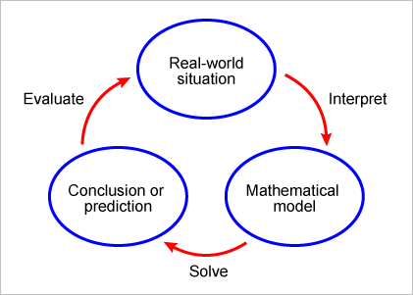

Here, we go into these steps in greater detail:

1. Given a real-world situation,*interpret the problem*. Familiarize yourself with the problem, name the independent and dependent variables, and make reasonable assumptions that simplify the situation sufficiently to enable you to develop a mathematical description. Use physical principles or empirical data to generate a mathematical representation that relates the independent and dependent variables. This representation can be an equation or a graph, depending on the situation.
2. Once you have established a mathematical model, *solve the mathematical expression(s)*. Apply mathematical techniques in solving the expression(s) to arrive at conclusions or to make predictions.
3. Once you have made a conclusion or a prediction, *evaluate the mathematical conclusion(s)*. Interpret your conclusion(s) and evaluate their merit based on the real-world situation. If the results are reasonable, then use them to make conclusions or predictions about the real-world situation. If the results are not reasonable, then redefine the mathematical model or develop a new one.

Although a mathematical model can reasonably approximate aspects of a real-world situation, it is important to understand that the models have limitations and to guard against relying on them absolutely.

A variety of functions can be used to model real-world situations. In this lesson, we will explore many key functions and the real-world situations they can model.

**2. Linear Models**

If *y* = *f*(*x*) is a **linear function** of *x*, then the graph of *y* = *f*(*x*) is a straight line. We use the slope-intercept form of a linear equation to write a formula for a linear function:

*y* = *f*(*x*) = *mx* + *b*

where *m* represents the slope or rate of change of *y* with respect to *x*, and *b* represents the *y*-intercept.

The formula for a linear equation can be used to model a real-world situation, as shown in the exercise below. In cases like this, we refer to the formula as a**linear model**.

**Exercise 1.2.1: Construct a Model for Weight as a Function of Height**

The National Heart, Lung, and Blood Institute (NHLBI), in cooperation with the National Institute of Diabetes and Digestive and Kidney Diseases (NIDDK), both part of the National Institutes of Health (NIH), define *overweight* as the condition of having a body mass index (BMI) higher than 25 (NHLBI, 1998). The data shown in table 1.2.1 indicate the weight *W* (in pounds) as a function of height *h* (in inches) for a BMI of 25 (the maximum healthy BMI).

**Problem**

Use the data in the table to construct a model for weight as a function of height for a BMI of 25.

**Table 1.2.1  
Height and Weight of Individuals with BMI 25**

|  |  |
| --- | --- |
| ***h*** | ***W*(*h*)** |
| 58 | 118 |
| 60 | 133 |
| 62 | 136 |
| 64 | 144 |
| 66 | 158 |
| 68 | 162 |
| 70 | 178 |
| 72 | 189 |
| 74 | 194 |
| 76 | 209 |

Data source: NHLBI, 1998, NHLBI Web site

**Solution**

When we plot the data points from table 1.2.1, we get the scatter plot shown in figure 1.2.2, where *h* represents the height in inches of individuals with BMI 25, and *W* represents the weight in pounds of individuals with BMI 25.

**Figure 1.2.2  
Weights and Heights of Individuals with BMI 25**

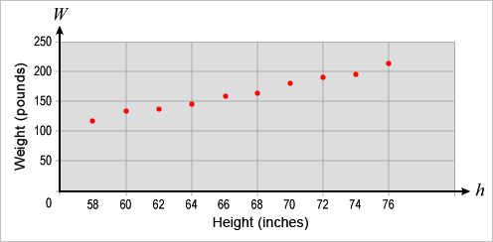

Because the data points follow a fairly linear pattern, it seems reasonable for us to use a linear model to represent the data. There are many lines from which we can choose, and there are many strategies we can use to obtain different linear models. One of the simpler strategies is to connect the first and last points of the data with a straight line.

We can find the equation of the line passing through the first point (58, 118) and the last point (76, 209) by computing the slope of the line:

https://umuc.equella.ecollege.com/file/7bdece95-b196-4233-9313-aa904663b08e/1/MATH140-0909.zip/Modules/M1-Module_1/Lesson_2/images/slopeline-fig1-2-2.gif

The equation of this line is

*W* – 118 = 5.06(*h* – 58)

or

*W* = 5.06*h* – 175.48 (Equation 1)

Equation 1 can be expressed in function notation as *W*(*h*) = 5.06*h* – 175.48.

This is one possible linear model for the weight of individuals with BMI 25. Figure 1.2.3 shows the equation graphed along with the data points:

**Figure 1.2.3  
Linear Model of Weight of Individuals with BMI 25**

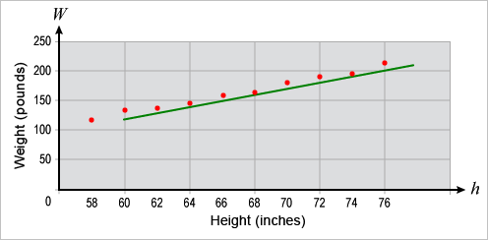

As you can see, a number of points fall below the line, which means that this particular linear model (although a reasonable fit) overestimates most of the weights. To correct this, we can use a statistical method called *linear regression*, which can be found in most graphing utilities.

**Note This**

|  |  |
| --- | --- |
| https://umuc.equella.ecollege.com/file/7bdece95-b196-4233-9313-aa904663b08e/1/MATH140-0909.zip/Modules/M1-Module_1/Lesson_2/images/NoteThisIcon.png | Most computers and graphing calculators use the method of least squares when determining the regression line. The **method of least squares** minimizes the sum of the squares of the vertical distances (change in *y*-values) between the actual data points and the regression line. Note that Equation 1 above is one example of a regression line. |

**Exercise 1.2.2: Approximate Weights with a Linear Model**

**Problem**

Use the linear model in the exercise above to approximate the weight of an individual 67 inches tall and to predict the weight of an individual 80 inches tall, both with a BMI of 25. According to the model, at what height will an individual with BMI 25 exceed 250 pounds?

**Solution**

Use *h* = 67 in the linear model to find the approximate weight of an individual with a BMI of 25.

*W*(67) = 5.06(67) – 175.48 = 163.54

This type of approximation is called an **interpolation**, as the value is approximated between known values. This approximation is reasonable, as the NIH estimates a weight of 161 pounds for an individual 67 inches tall with a BMI of 25.

Using *h* = 80 in our linear model, we predict the approximate weight of an individual with a BMI of 25:

*W*(80) = 5.06(80) – 175.48 = 229.32

Using this model, we predict that an individual 80 inches tall with a BMI of 25 will weigh 229.32 pounds. This kind of approximation is called an **extrapolation**, as the value is approximated or predicted outside the known values.

**Note This**

|  |  |
| --- | --- |
| https://umuc.equella.ecollege.com/file/7bdece95-b196-4233-9313-aa904663b08e/1/MATH140-0909.zip/Modules/M1-Module_1/Lesson_2/images/NoteThisIcon.png | Extrapolating information from data—that is, making predictions about data outside known values—does not yield as certain a result as interpolating information. |

Going back to our model, we find that an individual with a BMI of 25 exceeds 250 pounds when

5.06*h* – 175.48 > 250

That is, when

https://umuc.equella.ecollege.com/file/7bdece95-b196-4233-9313-aa904663b08e/1/MATH140-0909.zip/Modules/M1-Module_1/Lesson_2/images/lesson2-ex1-2-2-NT-eq1.gif

Based on our linear model, we therefore predict that an individual with a BMI of 25 will exceed 250 pounds at a height of 84.09 inches. This prediction may not be accurate, however, as it is an extrapolation somewhat far from the known data.

**3. Polynomial Functions**

The next function that we will discuss is the polynomial function.

A **polynomial** *p* is a function of the form

*p*(*x*) = *anxn* + *a*n – 1*xn*– 1 + ... + a1*x* + a

where a*n*, a*n*– 1, ..., a1, and a are constants called **coefficients** (*an* ≠ 0), and *n* ≥ 0 is an integer.

The domain for any polynomial function is all real numbers, *R* = (–∞, ∞). The **leading term** of the polynomial function is *anxn*, the **leading coefficient** is *an*, and the **degree** of the polynomial function is *n*. For example, the degree is 10 of the following polynomial function:

https://umuc.equella.ecollege.com/file/7bdece95-b196-4233-9313-aa904663b08e/1/MATH140-0909.zip/Modules/M1-Module_1/Lesson_2/images/sec3-polynom-func1.gif

A polynomial of degree 1 is a linear function of the form *p*(*x*) = *a*1*x* + *a*. A polynomial of degree 2 is a **quadratic function** of the form *p*(*x*) = *a*2*x*2 + *a*1*x* + *a*. The graph of a quadratic function is a parabola. The parabola opens upward if *a* > 0, and downward if*a*< 0 (see figure 1.2.4).

**Example 1.2.1: Polynomial Graphs**

Here are some graphed examples of polynomials:

1. *p*(*x*) = 3 is a polynomial of degree 0, or a **constant polynomial**, also called a *constant function*.

**Figure 1.2.4  
Constant Polynomial (of Degree 0)**

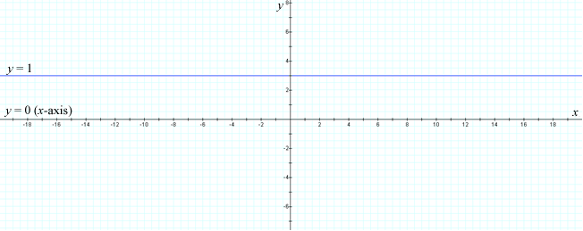

1. *p*(*x*) = 2*x* – 5 is a polynomial of degree 1, or a **linear polynomial**.

**Figure 1.2.5  
Linear Polynomial (of Degree 1)**

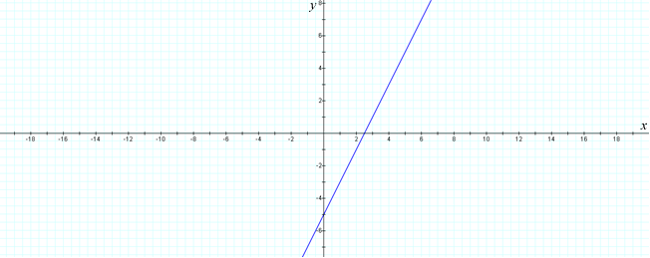

1. *p*(*x*) = *x*2 – 2*x* + 2 is a polynomial of degree 2, or a **quadratic polynomial**.

**Figure 1.2.6  
Quadratic Polynomial (of Degree 2)**

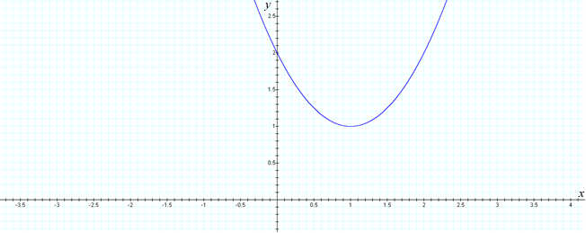

1. *p*(*x*) = *x*3 – *x*2 – *x* + 1 is a polynomial of degree 3, or a **cubic polynomial**.

**Figure 1.2.7  
Cubic Polynomial (of Degree 3)**

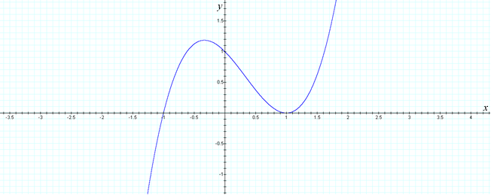

1. https://umuc.equella.ecollege.com/file/7bdece95-b196-4233-9313-aa904663b08e/1/MATH140-0909.zip/Modules/M1-Module_1/Lesson_2/images/Math140-fig1-2-7e-eq.gif is a polynomial of degree 4, or a **quartic polynomial**.

**Figure 1.2.8  
Quartic Polynomial (of Degree 4)**

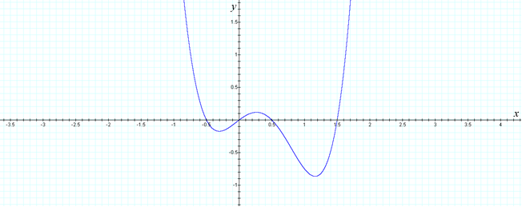

1. https://umuc.equella.ecollege.com/file/7bdece95-b196-4233-9313-aa904663b08e/1/MATH140-0909.zip/Modules/M1-Module_1/Lesson_2/images/Math140-fig1-2-7f-eq.gif = is a polynomial of degree 5, or a **quintic polynomial**.

**Figure 1.2.9  
Quintic Polynomial (of Degree 5)**

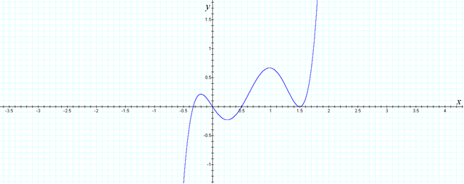

**Note This**

|  |  |
| --- | --- |
| https://umuc.equella.ecollege.com/file/7bdece95-b196-4233-9313-aa904663b08e/1/MATH140-0909.zip/Modules/M1-Module_1/Lesson_2/images/NoteThisIcon.png | You may have observed a relationship between the degree of the polynomial and the shape of its graph. We will further investigate the graphs of polynomials and their shapes in module 4. |

***Counter*Point:** The expression https://umuc.equella.ecollege.com/file/7bdece95-b196-4233-9313-aa904663b08e/1/MATH140-0909.zip/Modules/M1-Module_1/Lesson_2/images/Math140-fig1-2-7f-counterpt.gif is *not* a polynomial, as https://umuc.equella.ecollege.com/file/7bdece95-b196-4233-9313-aa904663b08e/1/MATH140-0909.zip/Modules/M1-Module_1/Lesson_2/images/Math140-fig1-2-7f-counterpt2.gif has exponents that are not greater than or equal to zero.

**Example 1.2.2: Graph of a Quadratic Regression Curve**

Figure 1.2.10 shows the scatter plot from Example 1.1.3 in lesson 1. This scatter plot describes the median number of hours Americans spend on work as a function of time (years). We can enter the data used to create the scatter plot, shown in table 1.2.2, into the data editor of a graphing calculator and choose the quadratic regression command. The graphing calculator gives us the following quadratic model:

*H* = –0.008 *t*2 + 0.781*t* + 40.612

We can then graph the quadratic regression curve on the scatter plot and observe that this model is a reasonable approximation of the data points.

**Figure 1.2.10  
Median Number of Hours Americans Spend on Work per Week (1970 –2010)**

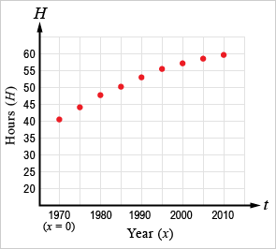

Data source: Harris Interactive Inc., 2008, HarrisInteractive Web site

In Example 1.1.3 of the previous topic, the data were arranged thus:

**Table 1.2.2  
Hours Spent on Work per Week, by Year**

|  |  |
| --- | --- |
| **Year (*x*)** | **Hours (*H*) Spent on Work per Week** |
| 1970 | 40.56 |
| 1975 | 44.34 |
| 1980 | 47.71 |
| 1985 | 50.69 |
| 1990 | 53.26 |
| 1995 | 55.44 |
| 2000 | 57.21 |
| 2005 | 58.59 |
| 2010 | 59.96 |

Data source: Harris Interactive Inc., 2008, HarrisInteractive Web site

**4. Power Functions**

A **power function** is a function of the form *f*(*x*) = *axr*, where *a* and *r* are non-zero constants. There are a number of cases for different values of the constant *r*. We will consider the following:

* *r* = *n*, (*n* is a natural number)
* *r* = https://umuc.equella.ecollege.com/file/7bdece95-b196-4233-9313-aa904663b08e/1/MATH140-0909.zip/Modules/M1-Module_1/Lesson_2/images/1-ovr-n-bold.gif, (*r* is a natural number)
* *a* = –*r*, (*r* is a natural number)

***r* = *n*, (*n* is a natural number)**

Figures 1.2.11a through 1.2.11e show the graphs of *f*(*x*) = *xn*, *n* = 1, 2, 3, 4, 5.

**Figure 1.2.11a  
*f*(*x*) = *x*1**

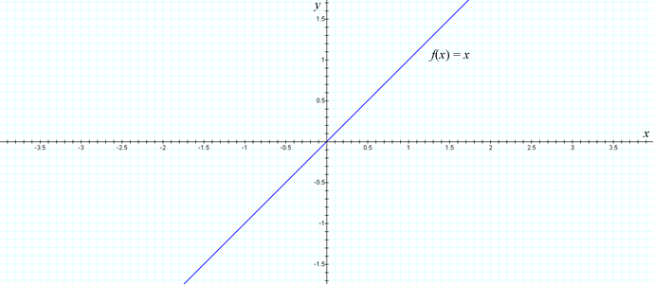

**Figure 1.2.11b  
*f*(*x*) = *x*2**

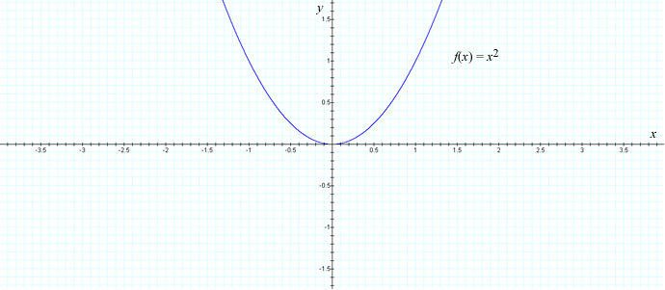

**Figure 1.2.11c  
*f*(*x*) = *x*3**

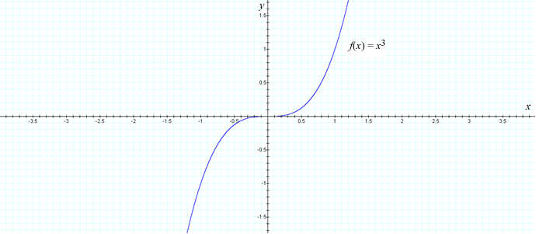

**Figure 1.2.11d  
*f*(*x*) = *x*4**

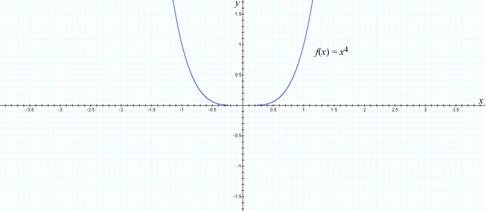

**Figure 1.2.11e  
*f*(*x*) = *x*5**

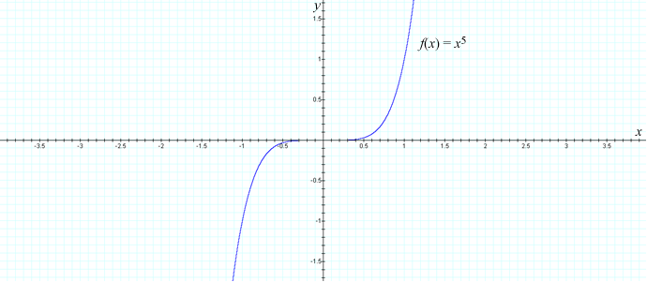

Observe in figures 1.2.12a and 1.2.12b how the graph of *f*(*x*) flattens toward the *x*-axis on the interval (–1, 1) and steepens for |*x*| > 1.

**Figure 1.2.12a  
Graph of *f*(*x*) I**

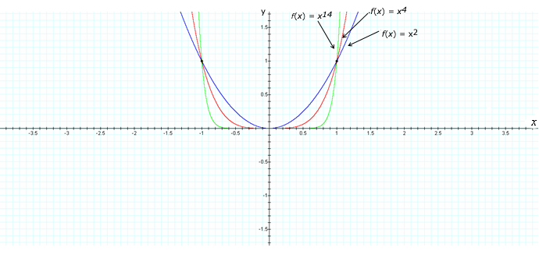

**Figure 1.2.12b  
Graph of *f*(*x*) II**

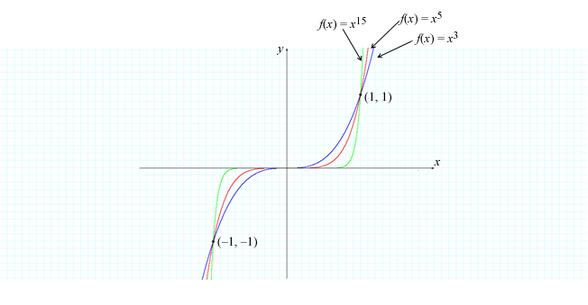

***r* = https://umuc.equella.ecollege.com/file/7bdece95-b196-4233-9313-aa904663b08e/1/MATH140-0909.zip/Modules/M1-Module_1/Lesson_2/images/1-ovr-n-bold.gif, (*r* is a natural number)**

Figures 1.2.13a through 1.2.13d show the graphs of *f*(*x*) = *x*1/*n* (*x* ≥ 0 if *n* is even), *n* = 2, 3, 4, 5.

**Figure 1.2.13a  
*f*(*x*) = *x*1/2**

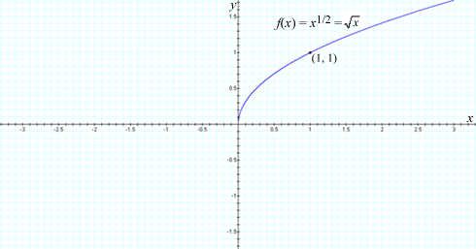

**Figure 1.2.13b  
*f*(*x*) = *x*1/3**

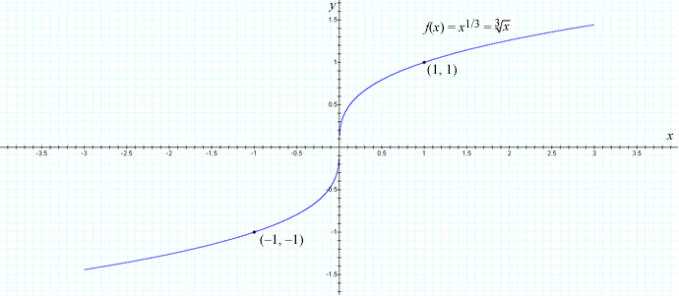

**Figure 1.2.13c  
*f*(*x*) = *x*1/4**

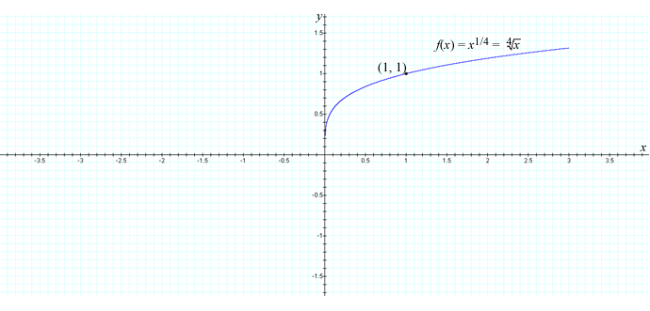

**Figure 1.2.13d  
*f*(*x*) = *x*1/5**

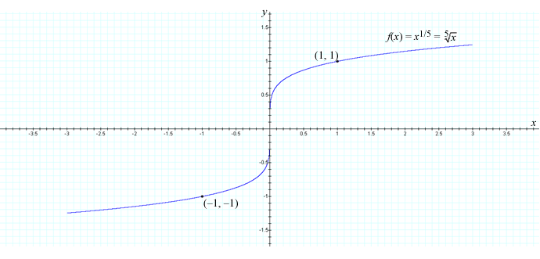

Observe in figures 1.2.14a and 1.1.14b how the graph of *f*(*x*) steepens as *x* approaches zero, and how it flattens horizontally for |*x*| > 1.

**Figure 1.2.14a  
*f*(*x*) III**

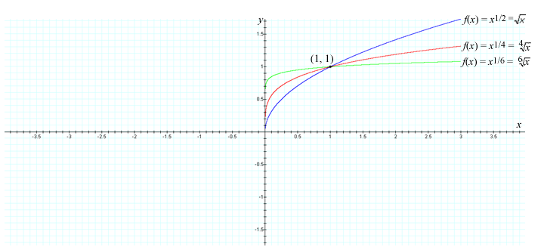

**Figure 1.2.14b  
*f*(*x*) IV**

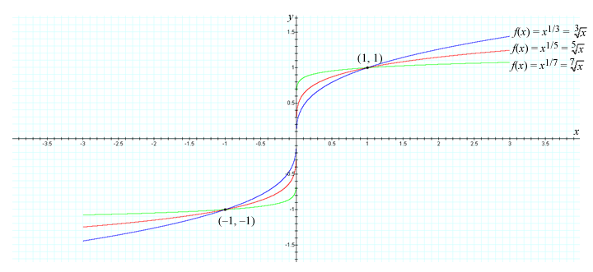

***a* = –*r*, (*r* is a natural number)**

The following figures illustrate the curves of rational functions of the form *f*(*x*) = 1/*x* and *f*(*x*) = 1/*x*2.

**https://umuc.equella.ecollege.com/file/7bdece95-b196-4233-9313-aa904663b08e/1/MATH140-0909.zip/Modules/M1-Module_1/Lesson_2/images/MATH140-lesson2-fig-1-2-15a-eq.gif**

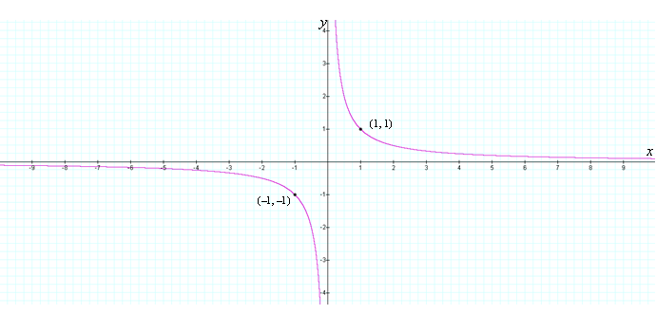

**https://umuc.equella.ecollege.com/file/7bdece95-b196-4233-9313-aa904663b08e/1/MATH140-0909.zip/Modules/M1-Module_1/Lesson_2/images/MATH140-lesson2-fig-1-2-16aa-eq.gif**

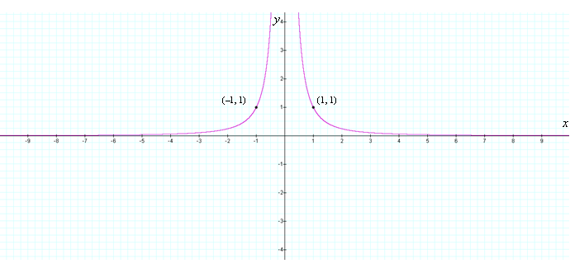

**Example 1.2.3: Rational Function Application**

The intensity *I* of light radiating from a particular source is inversely proportional to the square of the distance *r* from the source:

https://umuc.equella.ecollege.com/file/7bdece95-b196-4233-9313-aa904663b08e/1/MATH140-0909.zip/Modules/M1-Module_1/Lesson_2/images/MATH140-lesson2-ex-1-2-3-eq.gif

where*k*is a constant and *P* represents the total power radiated from a point source, so that an object three times farther than another object from a source of light radiation will receive an intensity of radiation nine times weaker.

**5. Rational Functions**

A **rational function** *f* is a function that can be expressed as a ratio of two polynomials:

https://umuc.equella.ecollege.com/file/7bdece95-b196-4233-9313-aa904663b08e/1/MATH140-0909.zip/Modules/M1-Module_1/Lesson_2/images/rational-func-eq.gif

where *p* and *q* are polynomials, and *q*(*x*) ≠ 0.

The domain of a rational function is the set of all real numbers *x* so that *q*(*x*) ≠ 0.

**Example 1.2.4: Rational Functions**

The functions below are rational functions:

1. https://umuc.equella.ecollege.com/file/7bdece95-b196-4233-9313-aa904663b08e/1/MATH140-0909.zip/Modules/M1-Module_1/Lesson_2/images/MATH140-lesson2-fig-1-2-16-eq.gif is a rational function whose domain is {*x* |*x* ≠ 3 or *x* ≠ –2}, or (–∞ , –2) ∪ (–2, 3) ∪ (3, ∞).

**https://umuc.equella.ecollege.com/file/7bdece95-b196-4233-9313-aa904663b08e/1/MATH140-0909.zip/Modules/M1-Module_1/Lesson_2/images/MATH140-lesson2-fig-1-2-17-head-eq.gif**

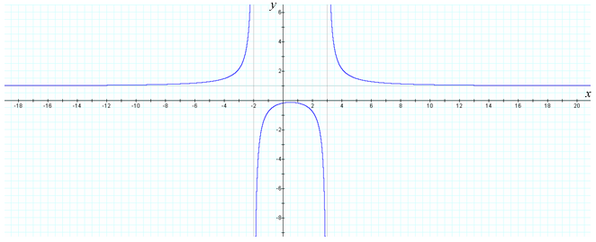

1. https://umuc.equella.ecollege.com/file/7bdece95-b196-4233-9313-aa904663b08e/1/MATH140-0909.zip/Modules/M1-Module_1/Lesson_2/images/MATH140-lesson2-fig-1-2-17b-eq.gif is a rational function whose domain is all real numbers, as the denominator can never be zero (*x*2 + 4 = 0 has no real solution).

**Figure 1.2.18  
https://umuc.equella.ecollege.com/file/7bdece95-b196-4233-9313-aa904663b08e/1/MATH140-0909.zip/Modules/M1-Module_1/Lesson_2/images/MATH140-lesson2-fig-1-2-18-eq.gif**

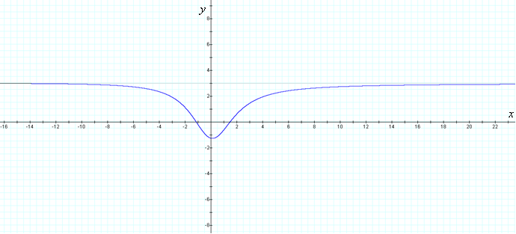

1. https://umuc.equella.ecollege.com/file/7bdece95-b196-4233-9313-aa904663b08e/1/MATH140-0909.zip/Modules/M1-Module_1/Lesson_2/images/MATH140-lesson2-fig-1-2-18c-eq.gif is a rational function whose domain is {*x* | *x* ≠ 1} or (–∞, 1) ∪ (1, ∞).

**https://umuc.equella.ecollege.com/file/7bdece95-b196-4233-9313-aa904663b08e/1/MATH140-0909.zip/Modules/M1-Module_1/Lesson_2/images/MATH140-lesson2-fig-1-2-19-eq.gif**

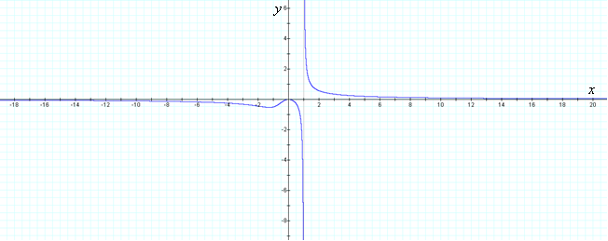

***Counter*Point:** The function https://umuc.equella.ecollege.com/file/7bdece95-b196-4233-9313-aa904663b08e/1/MATH140-0909.zip/Modules/M1-Module_1/Lesson_2/images/MATH140-lesson2-fig-1-2-19-eq2.gif is not a rational function, as it cannot be expressed as the ratio of two polynomials (https://umuc.equella.ecollege.com/file/7bdece95-b196-4233-9313-aa904663b08e/1/MATH140-0909.zip/Modules/M1-Module_1/Lesson_2/images/MATH140-lesson2-fig-1-2-19-eq3.gif is not a polynomial, as the exponent is not a natural number).

**6. Algebraic Functions**

An **algebraic function** *f* is any function that is defined using a finite combination of operations, such as addition, subtraction, and multiplication; or taking roots starting with polynomials. We have already discussed some algebraic functions: polynomials, power functions, and rational functions. Below are some additional algebraic functions and their graphs.

**Example 1.2.5: Algebraic Functions and Their Graphs**

1. graph of the function https://umuc.equella.ecollege.com/file/7bdece95-b196-4233-9313-aa904663b08e/1/MATH140-0909.zip/Modules/M1-Module_1/Lesson_2/images/MATH140-lesson2-ex1-2-5a-eq.gif

**https://umuc.equella.ecollege.com/file/7bdece95-b196-4233-9313-aa904663b08e/1/MATH140-0909.zip/Modules/M1-Module_1/Lesson_2/images/MATH140-lesson2-fig-1-2-20-eq.gif**

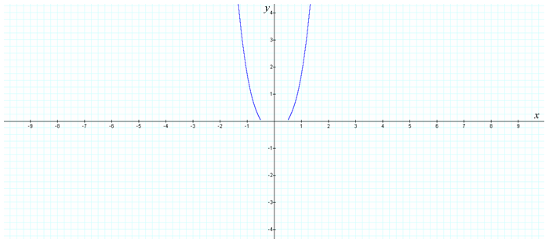

1. graph of the function https://umuc.equella.ecollege.com/file/7bdece95-b196-4233-9313-aa904663b08e/1/MATH140-0909.zip/Modules/M1-Module_1/Lesson_2/images/MATH140-lesson2-ex1-2-5b-eq.gif

**https://umuc.equella.ecollege.com/file/7bdece95-b196-4233-9313-aa904663b08e/1/MATH140-0909.zip/Modules/M1-Module_1/Lesson_2/images/MATH140-lesson2-fig-1-2-21-eq.gif**

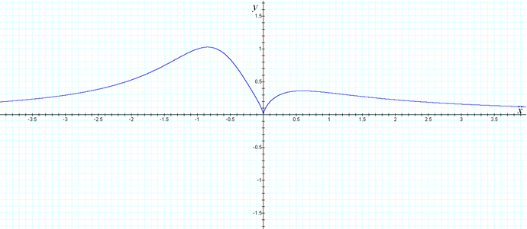

1. graph of the function https://umuc.equella.ecollege.com/file/7bdece95-b196-4233-9313-aa904663b08e/1/MATH140-0909.zip/Modules/M1-Module_1/Lesson_2/images/MATH140-lesson2-ex1-2-5c-eq.gif

**https://umuc.equella.ecollege.com/file/7bdece95-b196-4233-9313-aa904663b08e/1/MATH140-0909.zip/Modules/M1-Module_1/Lesson_2/images/MATH140-lesson2-fig-1-2-22-eq.gif**

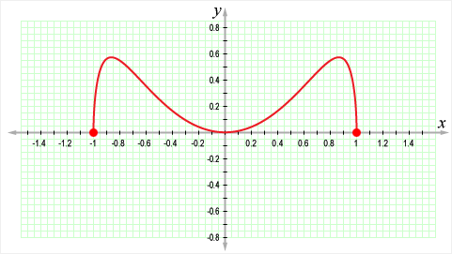

As there are a wide variety of algebraic functions, the graphs of these functions can take a variety of forms. In module 4, we will examine the graphs of algebraic functions more closely.

**7. Trigonometric Functions**

In calculus, angles are measured in radians, unless otherwise stated. Thus, we write *f*(*x*) = sin *x* to indicate the sine of an angle whose radian measure is *x*. You can see the graphs of the sine and cosine functions in figures 1.2.23a and 1.2.23b.

**Figure 1.2.23a  
*f*(*x*) = sin *x***

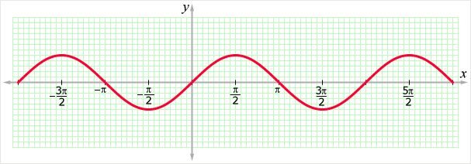

**Figure 1.2.23b  
*g*(*x*) = cos *x***

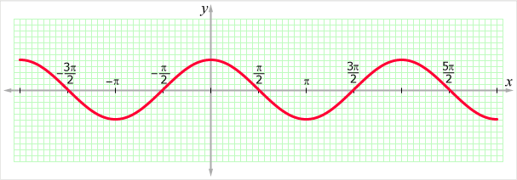

The domain of sin *x* is (–∞, ∞), and the domain of cos *x* is (–∞, ∞). The range of sin *x* and the range of cos *x* are the closed interval [–1, 1]. That is, for all *x*,

–1 ≤ sin *x* ≤ 1 AND –1 ≤ cos *x* ≤ 1

We can write the inequalities using absolute values:

|sin*x*| ≤ 1 AND |cos*x*| ≤ 1

The sine and cosine functions vanish under the following conditions:

sin *x* = 0 for *x* = *n*π, *n* is an integer

AND

cos *x* = 0 for *x* = *n*π/2, *n* is an integer

A function *f*(*x*) is a **periodic function** if *f*(*x* + *P*) = *f*(*x*) for all *x* in the domain of *f*, where *P* > 0 is a constant. The smallest such *P* is called the **period** of the function *f*.

For example, sin *x* and cos *x* are periodic functions with a period of 2π, and *y* = tan *x* is periodic function with a period of π. Therefore, we can write

|  |  |
| --- | --- |
| sin(*x* + 2π) = sin*x* | cos(*x* + 2π) = cos*x* |

**Note This**

|  |  |
| --- | --- |
| https://umuc.equella.ecollege.com/file/7bdece95-b196-4233-9313-aa904663b08e/1/MATH140-0909.zip/Modules/M1-Module_1/Lesson_2/images/NoteThisIcon.png | Periodic functions, such as sine and cosine, are good functions for modeling cyclical behavior, such as rising and falling sea surfaces, vibrations, tremors, sound waves, and seasonal events. |

**Exercise 1.2.3: Sketch Graphs of Trigonometric Functions**

**Problem**

Sketch the graphs of the following trigonometric functions:

1. *f*(*t*) = 3sin(2*t*)
2. *g*(*t*) = 1 + https://umuc.equella.ecollege.com/file/7bdece95-b196-4233-9313-aa904663b08e/1/MATH140-0909.zip/Modules/M1-Module_1/Lesson_2/images/1-ovr-2.gifsin *t*
3. *h*(*t*) = –2sin(*t*/2)

**Solution**

1. As shown in figure 1.2.24a, the graph of *f*(*t*) = 3sin(2*t*) is stretched vertically by a factor of 3. The period of *f*(*t*) = 3sin(2*t*) is 2π/2 = π, because, as *t* moves from 0 to 2*x* + 2π, the quantity 2*t* moves from 0 to *x* + 2π, enabling the sine function to complete one full cycle.

**Figure 1.2.24a  
*f*(*t*) = 3sin(2*t*)**

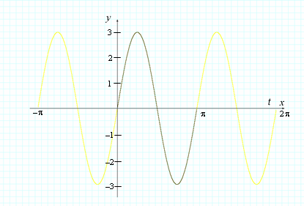

1. As shown in figure 1.2.24b, the entire graph is shifted vertically (upward) by one unit, and the amplitude of *g*(*t*) = 1 + https://umuc.equella.ecollege.com/file/7bdece95-b196-4233-9313-aa904663b08e/1/MATH140-0909.zip/Modules/M1-Module_1/Lesson_2/images/1-ovr-2.gifsin *t*is https://umuc.equella.ecollege.com/file/7bdece95-b196-4233-9313-aa904663b08e/1/MATH140-0909.zip/Modules/M1-Module_1/Lesson_2/images/1-ovr-2.gif, as the graph of https://umuc.equella.ecollege.com/file/7bdece95-b196-4233-9313-aa904663b08e/1/MATH140-0909.zip/Modules/M1-Module_1/Lesson_2/images/1-ovr-2.gifsin *t* is stretched vertically by a factor of one-half (half the distance between the maximum and minimum values is https://umuc.equella.ecollege.com/file/7bdece95-b196-4233-9313-aa904663b08e/1/MATH140-0909.zip/Modules/M1-Module_1/Lesson_2/images/1-ovr-2.gif(1) = https://umuc.equella.ecollege.com/file/7bdece95-b196-4233-9313-aa904663b08e/1/MATH140-0909.zip/Modules/M1-Module_1/Lesson_2/images/1-ovr-2.gif). The period of *g*(*t*) = 1 + https://umuc.equella.ecollege.com/file/7bdece95-b196-4233-9313-aa904663b08e/1/MATH140-0909.zip/Modules/M1-Module_1/Lesson_2/images/1-ovr-2.gifsin *t* is 2π /1 = 2π, as the quantity *t* moves from 0 to 2π, enabling the sine function to complete one full cycle.

**https://umuc.equella.ecollege.com/file/7bdece95-b196-4233-9313-aa904663b08e/1/MATH140-0909.zip/Modules/M1-Module_1/Lesson_2/images/MATH140-lesson2-fig-1-2-24b-eq.gif**

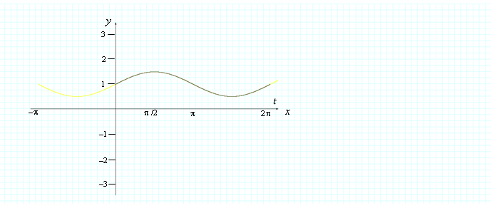

1. As shown in figure 1.2.24c, the graph of *h*(*t*) = –2sin(*t*/2) has an amplitude of 2, as the graph of *h* is stretched vertically by a factor of two (half the distance between the maximum and minimum values is https://umuc.equella.ecollege.com/file/7bdece95-b196-4233-9313-aa904663b08e/1/MATH140-0909.zip/Modules/M1-Module_1/Lesson_2/images/1-ovr-2.gif(4) = 2). The period of *h*(*t*) = –2sin(*t*/2) is 2π/(https://umuc.equella.ecollege.com/file/7bdece95-b196-4233-9313-aa904663b08e/1/MATH140-0909.zip/Modules/M1-Module_1/Lesson_2/images/1-ovr-2.gif) = 4π, because as *t* moves from 0 to 2π, the quantity *t*/2 moves from 0 to 4π, enabling the sine function to complete one full cycle. The negative coefficient (–2) reflects the graph through the horizontal axis.

**Figure 1.2.24c  
*h*(*t*) = –2sin(*t*/2)**

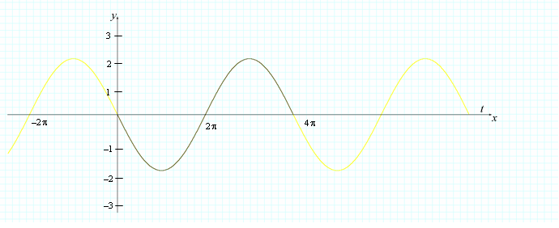

**Example 1.2.6: Trigonometric Function tan *x***

The tangent function is expressed in terms of sine and cosine functions with the following equation:

https://umuc.equella.ecollege.com/file/7bdece95-b196-4233-9313-aa904663b08e/1/MATH140-0909.zip/Modules/M1-Module_1/Lesson_2/images/MATH140-lesson2-example-1-2-6-eq.gif

Figure 1.2.25 illustrates this equation:

**https://umuc.equella.ecollege.com/file/7bdece95-b196-4233-9313-aa904663b08e/1/MATH140-0909.zip/Modules/M1-Module_1/Lesson_2/images/MATH140-lesson2-fig-1-2-25-eq.gif**

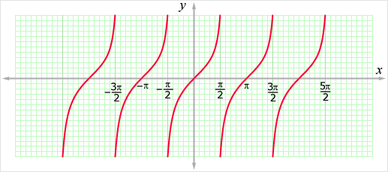

Notice that tan *x* is not defined when cos *x* = 0, which occurs whenever https://umuc.equella.ecollege.com/file/7bdece95-b196-4233-9313-aa904663b08e/1/MATH140-0909.zip/Modules/M1-Module_1/Lesson_2/images/MATH140-lesson2-fig-1-2-25-eq1.gifπ, *n* is an integer. In other words, *x* cannot be https://umuc.equella.ecollege.com/file/7bdece95-b196-4233-9313-aa904663b08e/1/MATH140-0909.zip/Modules/M1-Module_1/Lesson_2/images/MATH140-lesson2-fig-1-2-25-eq2.gif .

**Note This**

|  |  |
| --- | --- |
| https://umuc.equella.ecollege.com/file/7bdece95-b196-4233-9313-aa904663b08e/1/MATH140-0909.zip/Modules/M1-Module_1/Lesson_2/images/NoteThisIcon.png | The other trigonometric functions, cot *x*, sec *x*, and csc *x*, are defined in terms of sin *x* and cos *x*. |

**8. Exponential Functions**

An **exponential function** is any function of the form

*f*(*x*) = *bx*

where the base *b* is a positive real number and *b* ≠ 1. The domain of *f* is all real numbers.

**Note This**

|  |  |
| --- | --- |
| https://umuc.equella.ecollege.com/file/7bdece95-b196-4233-9313-aa904663b08e/1/MATH140-0909.zip/Modules/M1-Module_1/Lesson_2/images/NoteThisIcon.png | We exclude the base *b* = 1, as the function *f*(*x*) = 1*x* would give the constant function. We also exclude negative values for the base *b*, as this would require us to exclude a large number of values. For example, we would have to exclude any fractional value for *x* with an even denominator. |

Figure 1.2.26 shows the graphs of *f*(*x*) = 2*x*, *f*(*x*) = 2*–x*, *f*(*x*) = –2*x*, and *f*(*x*) = –2–*x*.

**Figure 1.2.26  
*f*(*x*) = 2*x*, *f*(*x*) = 2–*x*, *f*(*x*) = –2*x*, *f*(*x*) = –2–*x***

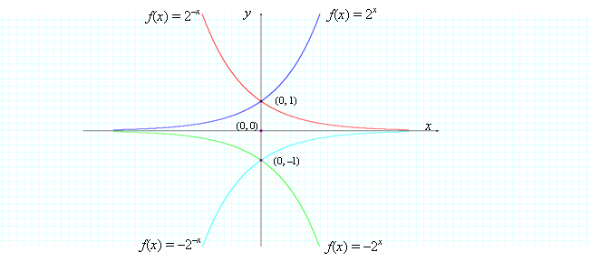

We will discuss exponential functions in greater detail later on, and we will see that these functions have a wide variety of applications in modeling population growth, radioactive decay, and a number of other interesting processes.

**Example 1.2.7: Scatter Plot, Exponential Model**

Figure 1.2.27 shows a scatter plot of the U.S. gross domestic product (GDP) from 1920 to 2010. As the data points appear to lie on an exponential curve, it seems fitting for us to use an exponential model for the data.

**Figure 1.2.27  
GDP Growth in the United States, 1920–2010**

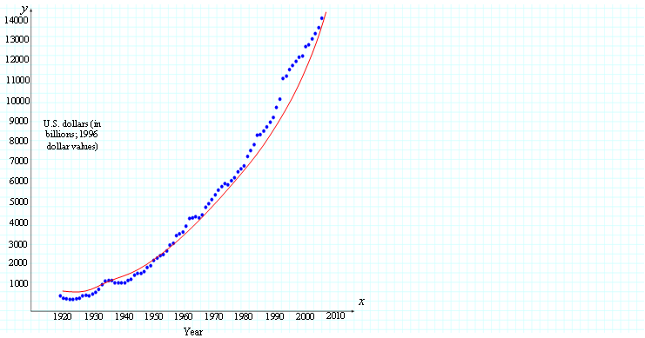

Data source: Heston et al., 2002, Wikipedia Web site

**9. Logarithmic Functions**

A **logarithmic function** is a function of the form *f*(*x*) = log*b* *x*, where *b* is a positive constant. Logarithmic functions are *inverse functions* of exponential functions.

**Note This**

|  |  |
| --- | --- |
| https://umuc.equella.ecollege.com/file/7bdece95-b196-4233-9313-aa904663b08e/1/MATH140-0909.zip/Modules/M1-Module_1/Lesson_2/images/NoteThisIcon.png | We write log *x* to indicate log10*x* and *ln* *x* to indicate log*e x*. |

**Figure 1.2.28  
Logarithmic Functions**

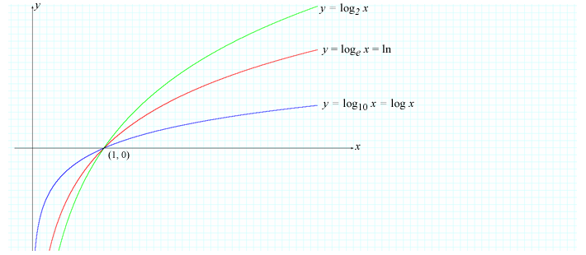

**Exercise 1.2.4: Find a Logarithmic Model**

You may recall from Exercise 1.1.1 in lesson 1 that the symbol *pH* stands for "potential for hydrogen" and is used to represent the acidic or alkaline level of a system. A pH level of 0 to 6.9 is acidic, and a pH level of 7 to 14 is alkaline. Table 1.2.3 lists the pH level *P*of a particular chemical solution with different concentrations *c* of hydrogen ions, measured in moles per liter.

**Table 1.2.3  
pH Levels of Chemical Solution**

|  |  |
| --- | --- |
| ***c*** | ***P*** |
| .001 | 3 |
| .007 | 2.15 |
| .010 | 2 |
| .050 | 1.30 |
| .073 | 1.14 |
| .100 | 1 |
| .250 | 0.6 |
| .360 | 0.44 |
| .500 | 0.3 |
| .750 | 0.12 |
| 1.000 | 0.001 |

**Problem**

Find a model for the pH level.

**Note This**

|  |  |
| --- | --- |
| https://umuc.equella.ecollege.com/file/7bdece95-b196-4233-9313-aa904663b08e/1/MATH140-0909.zip/Modules/M1-Module_1/Lesson_2/images/NoteThisIcon.png | The range of this function is known to be 0 ≤*P* ≤ 14, where a pH level of 0 is most acidic, and a pH level of 14 is most alkaline. |

**Solution**

Construct a scatter plot (see figure 1.2.29) using the data from table 1.2.3, where *c* represents the concentration of hydrogen ions and *P* represents the pH level of the chemical compound.

**Figure 1.2.29  
Scatter Plot of pH Levels**

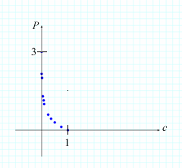

Observe that the data do not follow a linear pattern; however, the data points appear to lie on an inverted logarithmic curve (reflected through the horizontal axis). The following model reasonably approximates the pH level *P* of a chemical solution with a concentration *c* of hydrogen ions:

*P* = –log*c*

Figure 1.2.30 shows the graph of this model.

**Figure 1.2.30  
*P* = –log*c***

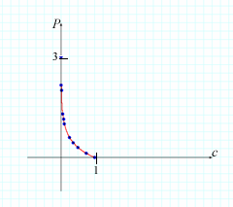

**10. Transcendental Functions**

Functions that are not algebraic are called **transcendental functions**. Trigonometric, exponential, and logarithmic functions are all transcendental functions, as they cannot be defined using algebraic operations. There are many other transcendental functions, as well.

**Exercise 1.2.5: Classify Functions**

Complete the activity below.

**References**

Clinical guidelines on identification, evaluation, and treatment of overweight and obesity in adults. (1998, September). National Heart, Lung and Blood Institute (NHLBI) Web site. Retrieved March 13, 2009, from http://www.nhlbi.nih.gov/guidelines/obesity/ob_home.htm

Leisure time plummets 20% in 2008—hits new low. (2008, December 4). Harris Interactive Inc. Web site. Retrieved March 13, 2009, from http://www.harrisinteractive.com/harris_poll/index.asp?PID=980

U.S. real GDP growth. (2002). Retrieved March 13, 2009, from Wikipedia: http://commons.wikimedia.org/wiki/File:Us_real_gdp_growth.gif

[*Return to top of page*](https://umuc.equella.ecollege.com/file/7bdece95-b196-4233-9313-aa904663b08e/1/MATH140-0909.zip/Modules/M1-Module_1/Lesson_2/S3-Commentary.html#pagetop)

[**Report broken links or any other problems on this page.**](http://help.umuc.edu/)  
  
[**Copyright © by University of Maryland University College.**](https://umuc.equella.ecollege.com/file/7bdece95-b196-4233-9313-aa904663b08e/1/MATH140-0909.zip/common/copyright.html)